Build a React App that allows the user to post pictures and a title along with the image like a social media feed.

1. Use create-react-app
   1. <https://github.com/facebook/create-react-app>
2. User should be able to enter a Image url
3. User should be able to enter a title with the image
4. When the user hits the submit button, the Feed should refresh and the new post should show up on the user feed.
5. Use css to make your social media feed app to look like the images below.



Image: <https://res.cloudinary.com/twenty20/private_images/t_watermark-criss-cross-10/v1450248078000/photosp/e41c1f0f-2ed5-4f78-b92b-9900340b5d1a/stock-photo-river-travel-adventure-walking-foot-feet-boots-hike-going-e41c1f0f-2ed5-4f78-b92b-9900340b5d1a.jpg>

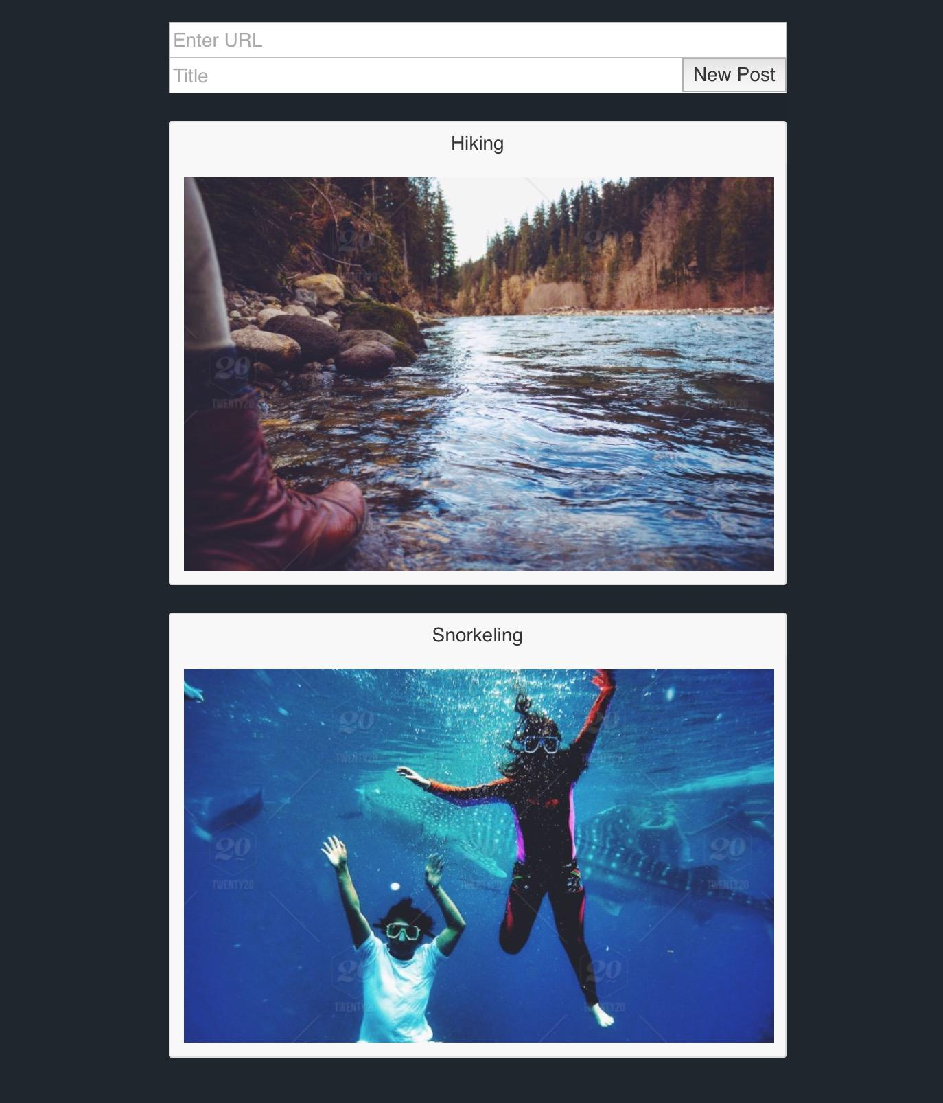

Image: <https://thumbs.dreamstime.com/z/zip-line-26475548.jpg>

Title: Zip lining

